

**American International University- Bangladesh**

**COE 3103: DATA COMMUNICATION**

**Mid Lab Report 03**

**Spring 2021-2022**

**Section: Q**

**Date: 18/02/2022**

**Submitted by,**

|  |  |
| --- | --- |
| Student Name | Student Id |
| Rahman, Sheikh Talha Jubayer | 19-41468-3 |

**Tasks**

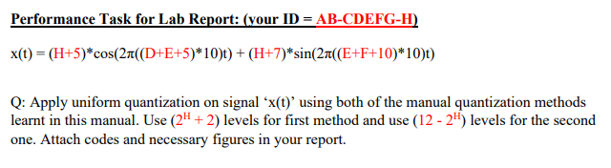

**Solution of Performance Task (Method 1)**

%ID: 19-41468-3

A = 1;

B = 9;

C = 4;

D = 1;

E = 4;

F = 6;

G = 8;

H = 3;

a1 = H+5; %a1 = 8

a2 = H+7; %a2 = 10

f1 = (D+E+5)*10; %f1 = 100

f2 = (E+F+10)*10; %f2 = 200

fs = 10000;

t = 0:1/fs:1;

x = (a1*cos(2*pi*f1*t)) + (a2*sin(2*pi*f2*t));

L = 2^H + 2; %L = 10

delta=(max(x)-min(x))/(L-1);

xq = min(x)+(round((x-min(x))/delta)).*delta;

plot(t,x,'r-.', 'linewidth',1.5);

hold on;

plot(t,xq,'k-.', 'linewidth',1.5);

axis([0 0.02 -20 20]);

title('Manual Quantization of Signal Using Method 1');

legend('Original signal','Quantized signal');

xlabel('Time (s)');

ylabel('Amplitude');



**Solution of Performance Task (Method 2)**

%ID: 19-41468-3

A = 1;

B = 9;

C = 4;

D = 1;

E = 4;

F = 6;

G = 8;

H = 3;

a1 = H+5; %a1 = 8

a2 = H+7; %a2 = 10

f1 = (D+E+5)*10; %f1 = 100

f2 = (E+F+10)*10; %f2 = 200

fs = 10000;

t = 0:1/fs:1;

x = (a1*cos(2*pi*f1*t)) + (a2*sin(2*pi*f2*t));

L = 12- 2^H; %L = 4

Am = (max(x)-min(x))/2;

Nsamples = length(x);

quantised_out = zeros(1,Nsamples);

del = (2*Am)/L;

Llow = -Am+del/2;

Lhigh = Am-del/2;

for i=Llow:del:Lhigh

for j=1:Nsamples

if(((i-del/2)<=x(j))&&(x(j)<=(i+del/2)))

quantised_out(j)=i;

end

end

end

plot(t,x,'r-.', 'linewidth',1.5);

hold on;

plot(t,quantised_out,'k-.', 'linewidth',1.5);

axis([0 0.02 -20 20]);

title('Manual Quantization of Signal Using Method 2');

legend('Original signal','Quantized signal');

xlabel('Time (s)');

ylabel('Amplitude');

